Technical Manual Leap Motion

HIT3061 – Software Team Project, Semester 2, 2013

**Leap Motion Project**

08

**Fall**

|  |  |
| --- | --- |
| **Joshua Stopper** | 5571391 |
| **Daniel Corsaletti** | 6450458 |
| **Minh Duc Nguyen** | 171001X |
| **Tran Xuong Tran** | 6700691 |
| **Shengwei Li** | 749999x |

**Table 1. Document Change Control**

|  |  |  |  |
| --- | --- | --- | --- |
| Version | Date | Author | Changes |
| 1.0 | 15/10/2013 | Minh Duc Nguyen | Create Document  Create Content Areas |

Table of Contents

Overview 2

Technical Requirements 2

## Overview

The purpose of this document is to help user easily for install the web application to their computer, required application and source code, required environment and source code overview for further development.

## Technical Requirements

WFLC algorithm implementation flag variable “WFLC_apply” is declared as global variable in “js/tremors.js” file line 16. The initial value of this variable is 0 indicating that WFLC algorithm is not applied.

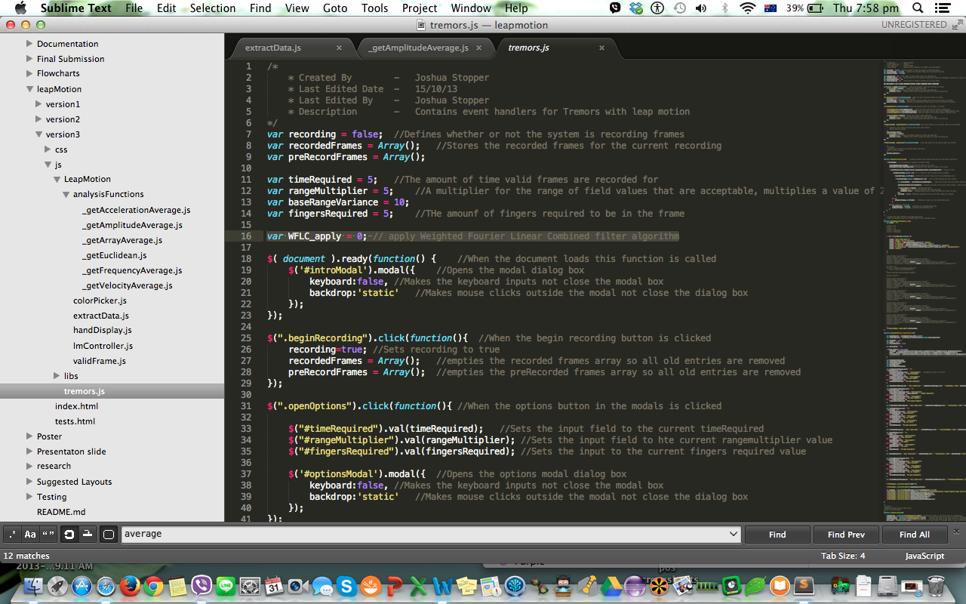

In the option modal in “index.php” page, the check box “Apply Weighted Fourier Linear Combined Filter Algorithm” is used to enable or disable WFLC algorithm in calculating output. The variable “WFLC_apply” value is 0 by the default and will be set to 1 if the check box “Yes” is ticked.

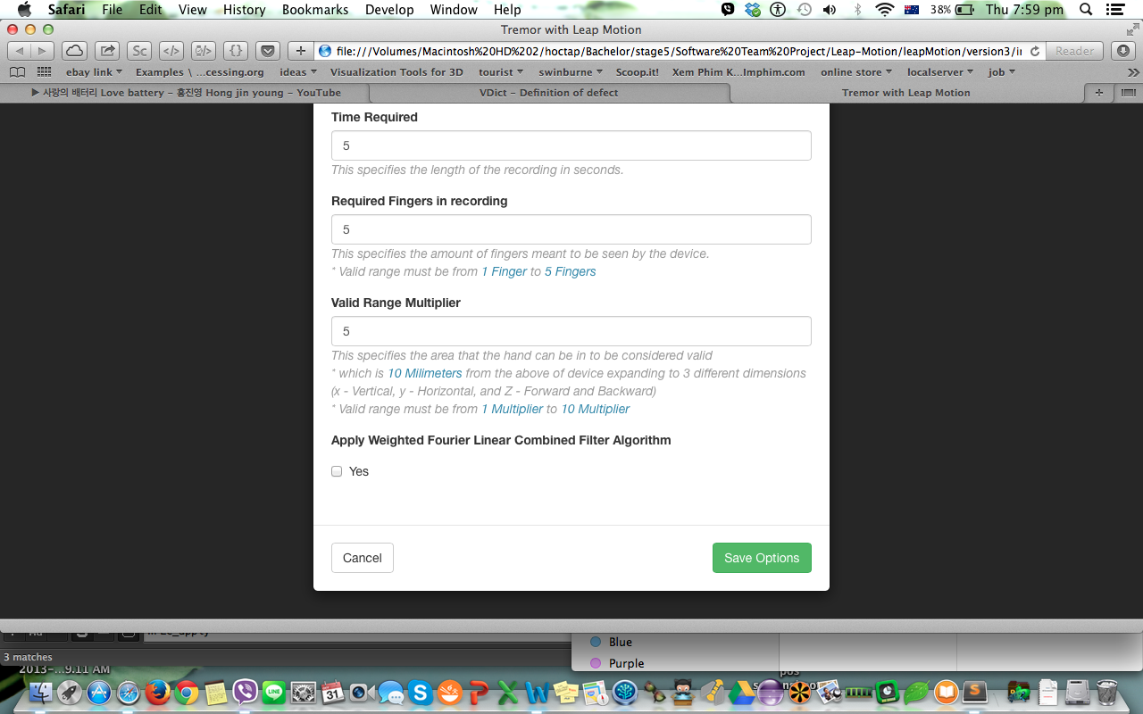

In “js/tremors.js” file, line 385, this statement gets the current checkbox status (tick / un-tick) and assign to the global variable “WFLC_apply”

## Macintosh HD:Users:ng0kylan:Desktop:Screen Shot 2013-10-31 at 7.59.18 pm.png

The WFLC implementation is defined in “js/LeapMotion/analysisFunctions/_getAmplitudeAverage.js” file at line 97. The accepted parameter is an array object that stores a set of Amplitude values during the capture. The purpose of this function is to read the “WFLC_apply” flag variable and apply WFLC filter algorithm if this flag value is 1 (selected on Option page as a checkbox). The output of this function is an array comprising a set of Amplitudes value that were cleaned using WFLC algorithm.

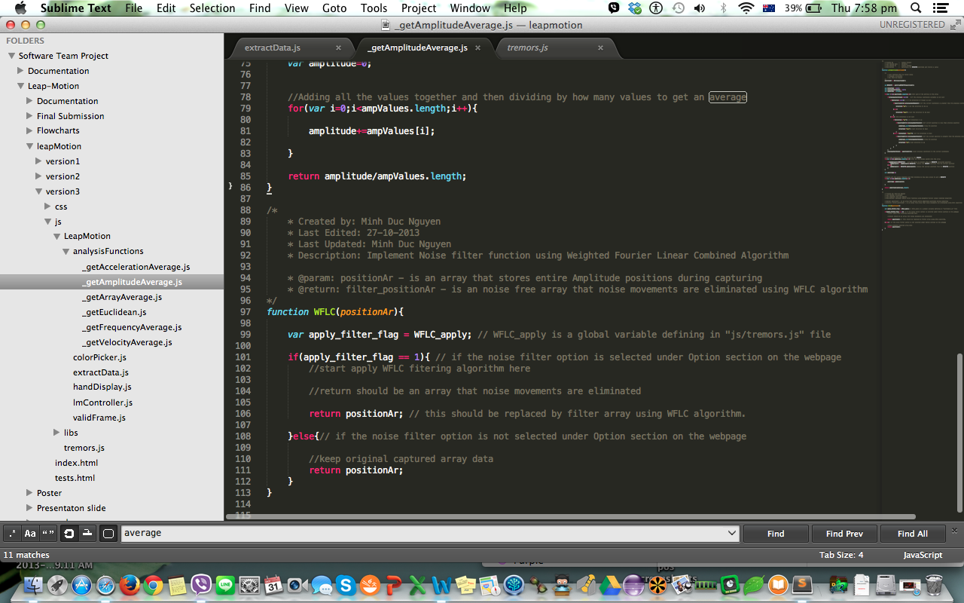

In “js/LeapMotion/analysisFunctions/_getAmplitudeAverage.js” file line 14, this statement calls the “WFLC” function before process Average Amplitude output to the report on screen.

